17.109: a) 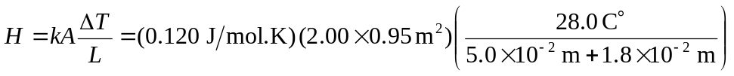
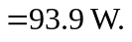
b) The flow through the wood part of the door is reduced by a factor of 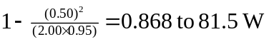. The heat flow through the glass is
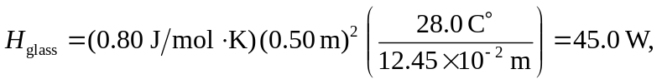
and so the ratio is 